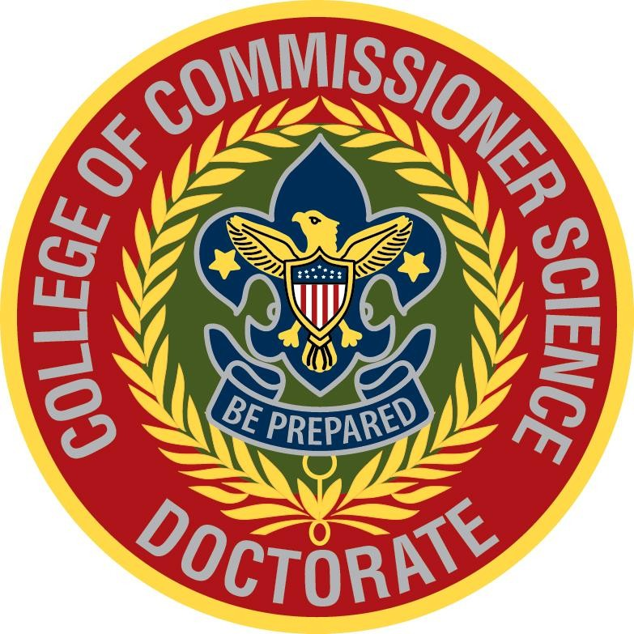

Candidate for Doctorate of Commissioner Science
PACCS Program, 2026

National has revised the program to be project-oriented only. The intent is that the commissioner's doctoral project should have a direct, practical impact on unit service by requiring candidates to identify a real, validated need and develop an evidence-based response to address it. It should support unit service in a very practical, hands-on way. Candidates should look closely at what units really need, listen to leaders, and use that information to create solutions that make a difference.

Rather than focusing on theory, the project helps improve how commissioners support units—whether that means more transparent communication, better tools, or stronger connections to resources. By putting these ideas into action and seeing what works, the project leads to meaningful improvements that help units run more smoothly and provide a better Scouting experience for youth and families.

This workbook, which includes both National and PACCS-specific information, is intended to assist both the candidate and their advisor in planning, carrying out, and documenting the work.

Doctorate of Commissioner Science Requirement

Note that the Doctoral Project is one of the requirements for the Doctorate of Commissioner Science Degree, but it is not the only requirement. Other requirements include
- current registration as a commissioner,
- current youth protection training,
- having earned the Masters of Commissioner Science degree,
- completing a required number of applicable College of Commissioner Science courses,
- serving on staff (at PACCS, for a degree from PACCS), and
- having earned the commissioner’s key.

Additionally, in order to receive a doctorate degree from PACCS, the candidate must
- attend the PACCS candidate course,
- attend the full weekend during the year in which the doctoral degree is awarded,
- give a 5-minute summary of project on Saturday to PACCS attendees, and
- earn all doctoral credit hours at PACCS.

See below for more detail on each of these requirements.

Project: It may be completed before or after the other requirements. The project is also to be documented in a report. Additional project and report details are covered later in this document.

Master’s Degree: Note that beginning in 2026, the Masters of Commissioner’s Science requirements include the coursework and having earned the commissioner’s arrowhead. PACCS does not require the commissioner’s arrowhead if the Masters degree was earned prior to 2026.

Hours and attendance requirement: The doctoral degree requires 10 hours of coursework and 5 of these hours must be from the National course curriculum. The remaining 5 hours are free electives, but they must not have already been claimed as hours in earning the Bachelor or Masters degree. The PACCS doctoral candidate course includes the 5 hours of courses from the National curriculum and 3 hours of electives, for a total of 8 hours; thus, the candidate still needs 2 additional hours to complete the classroom requirements. As noted above, a PACCS candidate must attend PACCS for the full weekend in the year in which the degree is awarded. The candidate can easily pick up the 2 remaining hours during the weekend in which he/she receives the doctoral award. Note that, in order to comply with National credit hour requirements, candidates may not be excused from attending any candidate class sessions.

Staff service: Candidates are also required to serve on staff at PACCS, teaching or otherwise assisting college operations. Candidates may not be excused from candidate course hours to serve on staff.

Working with Your Doctoral Advisor
Once you have completed the candidate course and have an approved project, you will be assigned an advisor to assist you with issues you may have completing your project. Once your project is complete and your report is drafted, the advisor will help you edit the report and then submit it the PACCS doctoral review board for final edits/approval.

It is good practice to share your work with your advisor regularly so you stay focused on your topic. A schedule for project completion and report drafting is included in this document. Report deadlines are firm and they are the candidate’s responsibility.

Doctoral Project Proposal Form (Draft)

Commissioner Name: ___________________________________________________________

Email Address: ___________________________________________________________

Cell Phone: ___________________________________________________________________

Council and District: ___________________________________________________________

Commissioner Position: _________________________________________________________

Name of Doctoral Project: _____________________________________________________

Date of Proposal: ___________________________________________________________

Briefly describe your project:

Describe how the project benefits unit service:

Describe how your project connects to you as a commissioner:

Doctoral Project Proposal Form (Final)

Commissioner Name: ___________________________________________________________

Email Address: ___________________________________________________________

Cell Phone: ___________________________________________________________________

Council and District: ___________________________________________________________

Commissioner Position: _________________________________________________________

Name of Doctoral Project: _____________________________________________________

Date of Proposal: ___________________________________________________________

Briefly describe your project:

Describe how the project benefits unit service:

Describe how your project connects to you as a commissioner:

Doctoral Project Work Schedule
Below, the person owning an action is in bold; however, in all cases, the candidate owns the paper’s completion and is to reach out for help if there is an adviser delay. If the candidate paper is not received on the schedule below, it will be considered for award of the degree the following year.

July 1 – candidate sends final project title to adviser and Chair of the Doctoral Candidate Review Board, if not already approved at the candidate course.

July 15 – candidate notified by adviser of final project approval (if not completed at candidate course).

October 15 – candidate to submit an outline of the project plan and current status to adviser and Chair of the Doctoral Candidate Review Board.

February 1 – candidate sends first draft of report to adviser for editing. This draft should be fully written and in the correct format (ie, as complete as the candidate can make it at that point).

March 1 – adviser edits of report are due to candidate.

April 1 – second draft (with adviser edits incorporated) is due from the candidate to the adviser. After a short review (1 or 2 days), the adviser is to send to the Chair of Doctoral Candidate Review Board for distribution to the entire review board.

May 1 – all reviews by members of the Doctoral Review Board are due back to the candidate and the adviser.

May 15 – final version of the paper in Word format is to be emailed by candidate to Chair of the Doctoral Candidate Review Board. No printed copies are requested.

June (typically) – Candidate attends Piedmont-Appalachian College of Commissioner Science. On Saturday night, candidate gives 5-minute presentation on the research project. Sunday morning is graduation and awarding of the PACCS Doctoral certificate, neckerchief, slide. Attendance for the full weekend is required.

Doctoral Project Report Format
Each college is required to maintain these reports in a reference library. In this way, all commissioners and future candidate can access ideas to improve unit service or future projects. Consistent formatting and appearance are important to make the library an organized and useful tool for all.

To this end, the format and content requirements are fairly simple and expected to be strictly followed. A template for formatting is embedded here and can be found at the web page, too.


Course Schedule for PACCS Session: Candidate for Doctorate of Commissioner Science
Each session is approximately 50 minutes with a 10 minute break between sessions. Courses taken from the National curriculum (5 in total) have a DCS designation. The PACCS designation are electives designed by PACCS to specifically focus on development of individual project topics via commissioners coaching each other (session 4) and project refinement/review with the Doctoral Review Board (sessions 6 and 7). The PACCS Doctoral Review Board is comprised of Council Commissioners (or their designee) from 7 different councils.

Session Title Course Number

1 Selecting and Limiting the Scope of Project DCS 501
2 Developing Your Doctoral Project DCS 502
3 Coaching Commissioners DCS 506
4 Applied Coaching for Project Proposals PACCS 597
5 Growing and Strengthening Our Unit Service Team DCS 516
6, 7 Doctoral Review Board: Refining Projects on PACCS 598/599
SMART Principles and Multi-Council Experience
8 Turning Relationships into Partnerships DCS 519

